Press Release
Rutland
Discover

FOR IMMEDIATE RELEASE
August 2023
DISCOVER RUTLAND SHOWCASES THE COUNTY OF GOOD TASTE WITH ANNUAL FOOD & DRINK WEEK
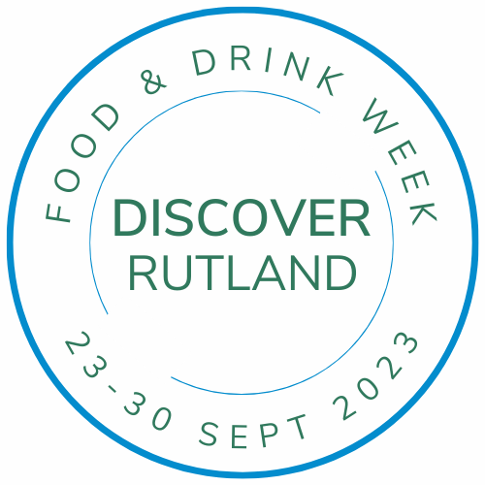
Rutland is well known for being a rural county bursting with fantastic food and drink producers, alongside an array of exceptional places to eat, hence being referred to as The County of Good Taste. Discover Rutland celebrates this with a collection of events, special menus and promotions throughout the Discover Rutland Food & Drink Week, which takes place 23rd – 30th September 2023.
There will be a range of events throughout the week, starting with Wine Tasting & Light Lunch at Hambleton Hall on 23rd, where Sommelier Dominique will introduce you to a flight of 7 fine wines form the new Spanish wine regions.
Browse the Artisan Market at Rockingham Castle on 23rd and 24th, showcasing a range of food, drink and craft produce on the stunning grounds, offering superb views over the Welland Valley.
Oakham will play host to the popular Rutland Food & Drink Festival on Sunday 24th 11am-4pm. Organised by Carolyn Acton Events, Oakham Castle grounds will by bustling with activities and there will be food, drink and craft stalls inside the castle, around the grounds and throughout the Market Place and Mill Street.
Beer lovers should book themselves a spot at The Olive Branch on Thursday 28th for their Round Corner Brewery Beer Dinner, an evening with a curated 6 course menu to match the range of classic, rare, seasonal and special beers inspired by the character of the brewery’s thriving agricultural home.
Plus there will be a Rutland Grape Grazing Festival at Mallard Point Vineyard & Winery on Saturday 30th, a Multum Gin Parvo Gin Bar at Rutland Nursery on 30th and The Grainstore Brewery’s Oktoberfest will be running from 28th September to 1st October.
Throughout the week you can enjoy the nature trail around The Rutland Vineyard near Ketton, or challenge yourself at the adventure golf at The Dairy Barn Café, where it’s almost obligatory to indulge in tasting one of their tempting homemade ice-cream flavours. Pop into one of our fantastic farm shop’s, from the smaller premises of Farmer Lou’s near Exton and Northfield Farm near Cold Overton, to the larger New Lodge Farm or Gates Farm Shop, you can support local producers, lower your food miles and eat scrumptious meals.
There will also be a range of promotions and special menus around the county, including at Ovation Wine & Spirit Bar, The George, GA Kitchen and Warner’s Traditional Sweets in Oakham, Lake Isle, The Falcon, Don Paddy’s and The Vaults in Uppingham plus Farmer Lou’s, Hoggy’s Grill, The Fox, The Olive Branch, The White Horse and Castle Chase Beef.
Tune into Rutland and Stamford Sound throughout the week and see www.discover-rutland.co.uk/food-week for more details.
Discover Rutland will also be launching the new Rutland Food & Drink Trail, which highlights the range of fantastic producers, eateries and farm shops in the area, plus it features two new cycle trails to help you explore the county.
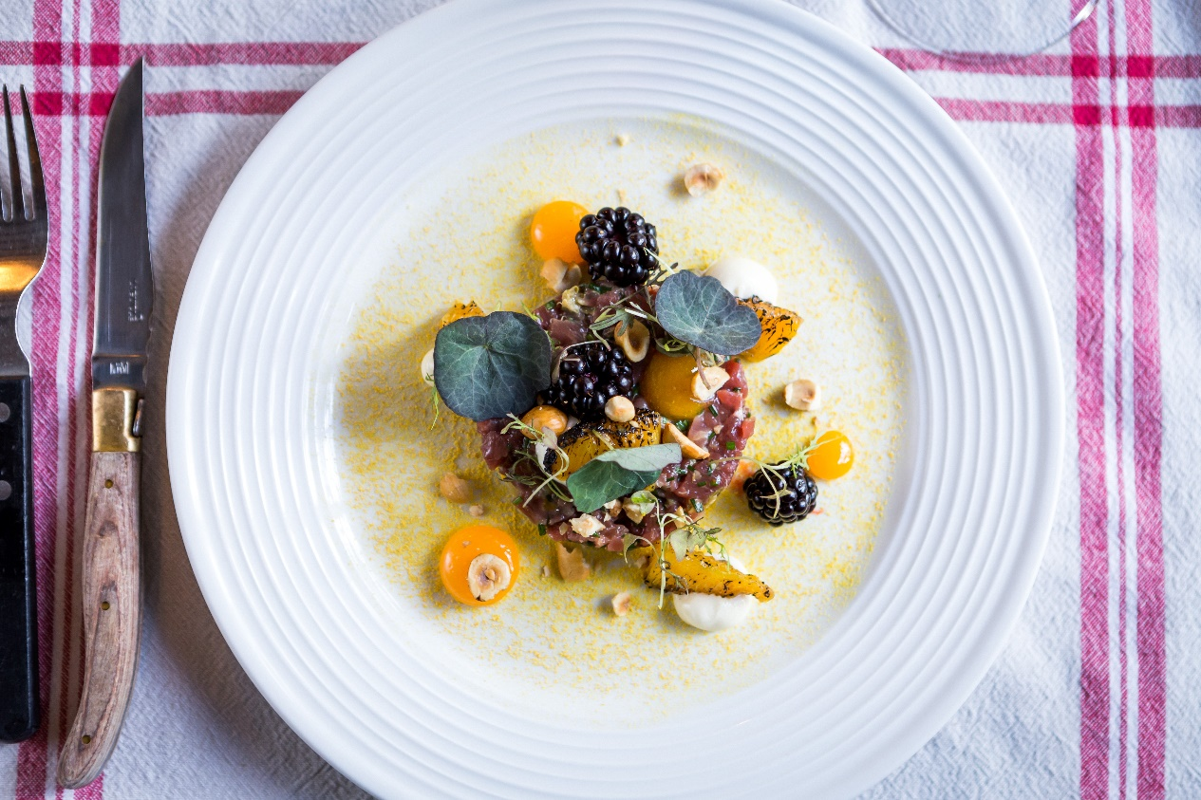

#ENDS#
Notes to editors:
For more information contact Mary Copley at Discover Rutland on 01572 720921 or email tourism@rutland.gov.uk
Rutland is a rural county with a population of fewer than 40,000. There are no cities and its two small market towns are filled with local producers and surrounded by chocolate box villages and agricultural land, giving it the tag-line “The county of good taste”.
About Discover Rutland
Discover Rutland is an independent DMO for the county of Rutland made up of a board of volunteers from the county who are passionate about promoting the area and represent members locally, nationally and internationally.
As a not-for-profit all money from memberships goes back into promotion and strategy.
For more information visit www.discover-rutland.co.uk
Mary Copley, Tourism Officer
tourism@rutland.co.uk | 01572 720921
www.discover-rutland.co.uk
Discover Rutland, Rutland County Council, Catmose, Oakham, LE15 6HP

